**Project Setup by Project Owner**

Table of Contents

I. Claim project 1

A. Reassign the Project to yourself as Project Owner. (If notified by Bell Icon) 1

B. Reassign the Project to yourself as Project Owner. (If no notification arrived) 1

II. Review Project Attachments 4

III. Review Project Setup 6

A. Additional Information Tab - Opportunity Number 6

B. General Tab – Project Details 6

C. Documents Tab – OF, DPM & CRF 7

D. Project Plan 8

IV. Enter SAS Cost and Revenue budget 9

A. Validation of Revenue, Cost & Billable Hours 9

B. Approve Project 11

V. Exception in Project Setup 12

A. Italy (530) 12

B. Norway (630) 13

C. Denmark (520) & Finland (600) 15

D. Philippines (430), Singapore (435), Malaysia (436) and Thailand (437) 15

Table of Versions

|  |  |  |
| --- | --- | --- |
| Sr. No. | Date | Version |
| 1 | 30/01/2025 | SAS-PRO-SOP-V1 |
| 2 | 04/04/2025 | SAS-PRO-SOP-V2 |
| 3 | 04/11/2025 | SAS-PRO-SOP-V3 |

# Claim project

## Reassign the Project to yourself as Project Owner. (If notified by Bell Icon)

1. Reassign ‘Action Required; Project Status Change Approval’ notification to SCA project owner.
2. Click the bell notification in the upper righthand corner
3. Find the notification for ‘Action Required: Project Status Change Approval for Project XYZ (1234)’ Click the link to open a new window.
4. Actions - Reassign
5. Search for your name, Submit.

## Reassign the Project to yourself as Project Owner. (If no notification arrived)

1. Click on Project > Project Financial Management > Enter Project Number and Project status drop down select ‘All’ > Click on Search.

1. Click on Project Number > Task bar > Manage Financial Project Settings

1. Parties > Select previous Project Owner > Click on pen icon > Add end date (preferably one day prior)

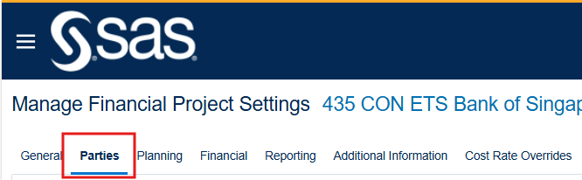

1. Click on “+” button > Search for your name > Add “Project Owner” as Project Role > Enter Start Date (Today’s date) > Save and Close

# Review Project Attachments

1. Project Owner will review project attributes and documents needed to set up the project
2. Click on Project > Project Financial Management > Enter Project Number and Project status drop down select ‘All’ > Click on Search.

1. Click on Project Number > Go to Documents Tab. (Note: Please check Oder Form, DPM and Contract Record Form is uploaded to documents tab)

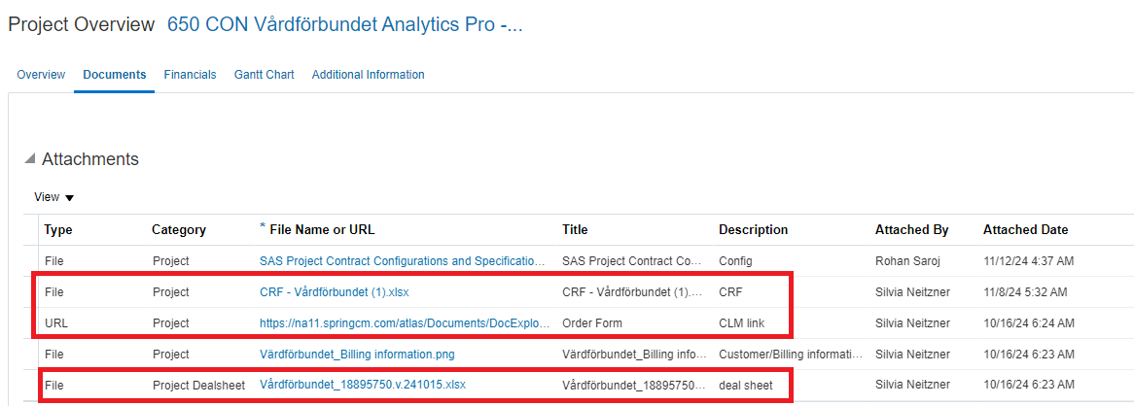

1. Confirm Order Form (CLM Link) is attached in the Documents tab. If missing, reject project
2. Confirm DPM (Dealsheet) is attached in the Documents tab. If missing, reject project
3. Confirm Contract Record Form (CRF) is attached in Documents tab. If missing, reject project
4. Confirm Opportunity Number is listed in Additional Information Tab. If missing, reject project
5. Confirm Project Currency matches the currency in customer agreement in Financial Tab. If incorrect currency is in the project, reject project
6. Locate the signed customer contract

# Review Project Setup

## Additional Information Tab - Opportunity Number

1. Opportunity should be filled in – if missing, reject project. Confirm that Opportunity Number matches the Opportunity Number in the DPM/Dealsheet

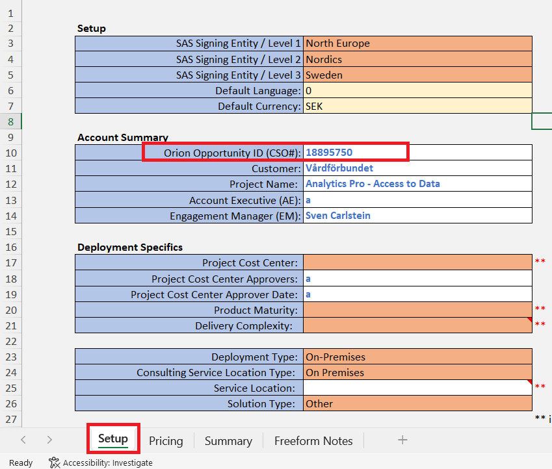

## General Tab – Project Details

1. Review Project Name and adjust using Edit button if needed
2. “Country Code CON Customer Name Contract Number Supplement Number”; example: “650 CON Vårdförbundet C99472-9947220241015”

1. Confirm Cost Centre/Organization Number
2. Review project description field and revise as necessary

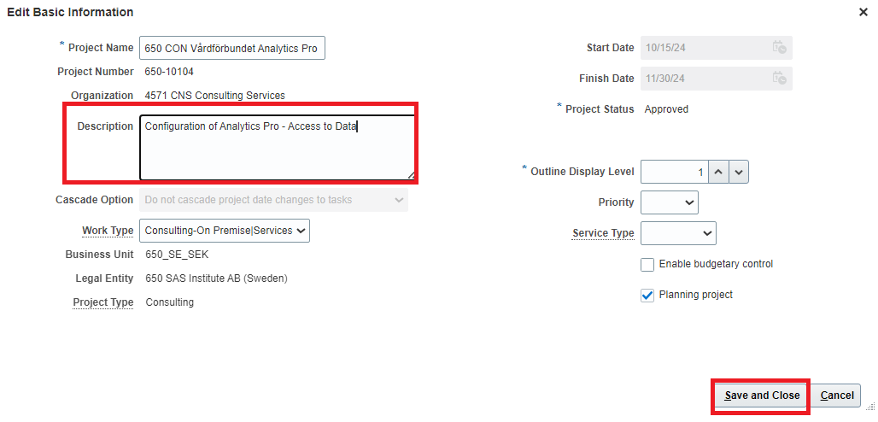

## Documents Tab – OF, DPM & CRF

1. Ensure there is a Project Dealsheet (DPM)
2. Ensure there are no contract attachments in the Documents page
3. If there is a customer contract attachment
4. update the attachment file to a URL link to CLM (Edit, + to add line, type = URL, paste link to document in CLM)
5. Delete attachment document line by using Edit, select line, “X”, save and close

## Project Plan

1. Open taskbar on righthand side of page → Manage Financial Project Plan

1. View → Expand All tasks

1. Confirm that Organization is the same on all lines

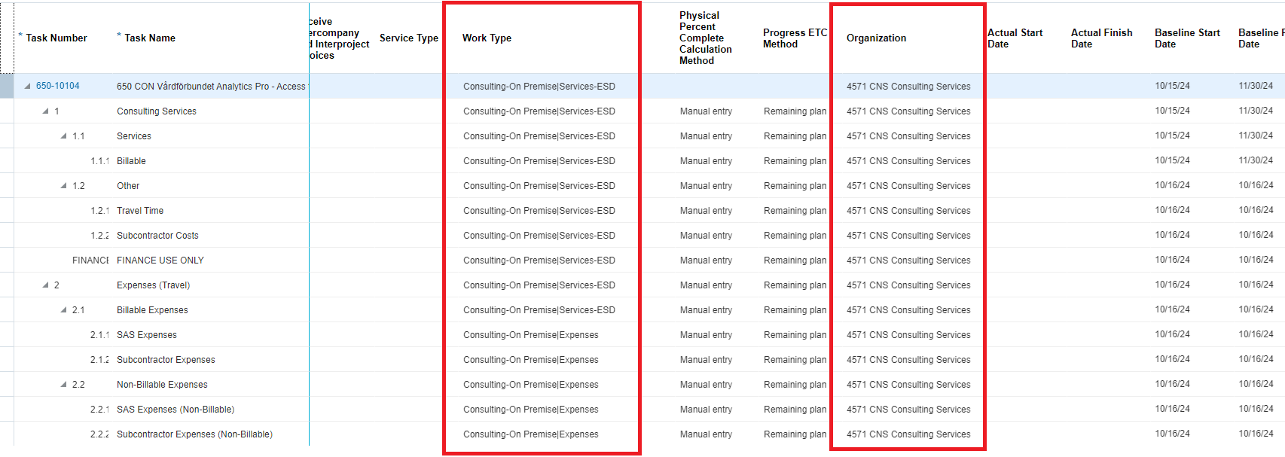

# Enter SAS Cost and Revenue budget

## Validation of Revenue, Cost & Billable Hours

1. Open DPM/Dealsheet, navigate to GAAP Finance View tab in DPM (see separate instructions to open hidden tab)

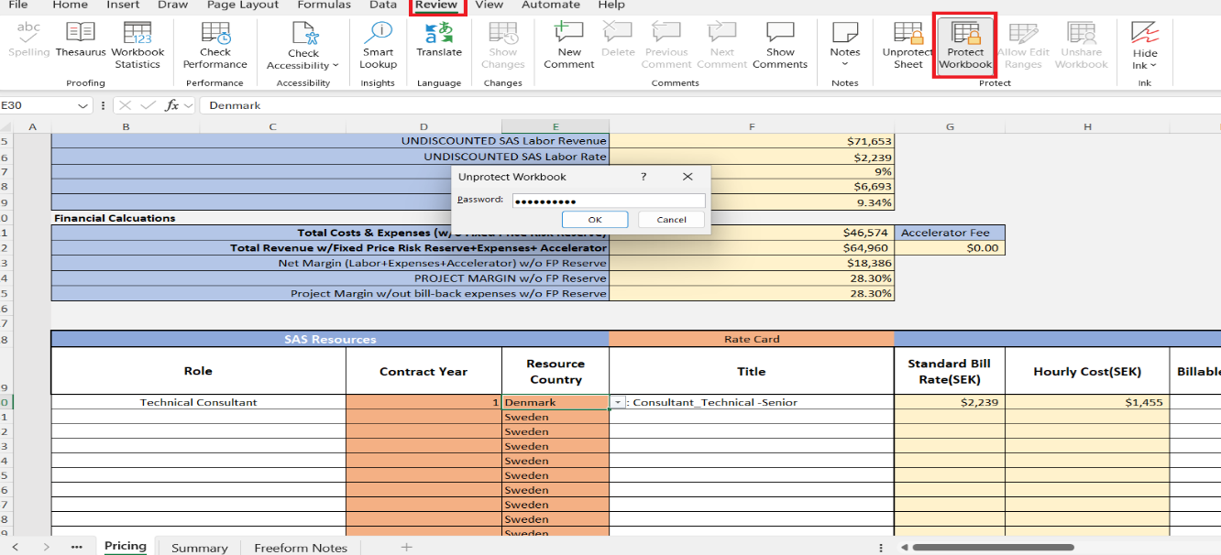

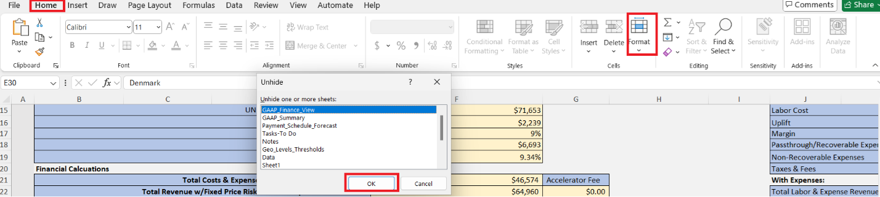

1. Taskbar → Manage Project Budget

1. Open Version 1 link (SAS Project Financial Budget)

1. Open Planning Options link

1. Expand Budget Creation Details → Additional Information
2. Add funding category (Original or Amendment)
3. Add latest date contract was signed
4. Enter Opportunity Number, Save and Close

1. Expand 1 line
2. In “Labor” line enter
3. Quantity = Total labor hours from DPM or Dealsheet
4. Revenue = Total labor value of contract document. **Do not use DPM value**
5. Raw Cost = Total labor cost from DPM GAAP Finance View Tab
6. Ensure margin is correct in Fusion as per DPM GAAP Finance View Tab

1. Submit
2. Uncheck both selections: ‘Add project attachments to workflow notification’ and ‘Add budget attachments to workflow notification’. No boxes should be checked
3. Budget is auto approved and baselined – Click refresh button and confirm no rejection

## Approve Project

1. Click the bell notification in the upper right-hand corner and locate ‘Project Status Approval for Project’ notification → Approve

1. Project status should now be Chargeable
2. PM will Submit for Approved status, Project Owner will receive notification to approve “Approved” status. No further review necessary to approve for “Approved” status.

# Exception in Project Setup

## Italy (530)

1. While setting up a project, go panel draw click on Manage Financial Project Setting

1. Click on Additional Information Tab
2. In Context Prompt checkbox select “Invoice Italy”

1. In Tax Type checkbox, refer the copy of customer and put the comments accordingly

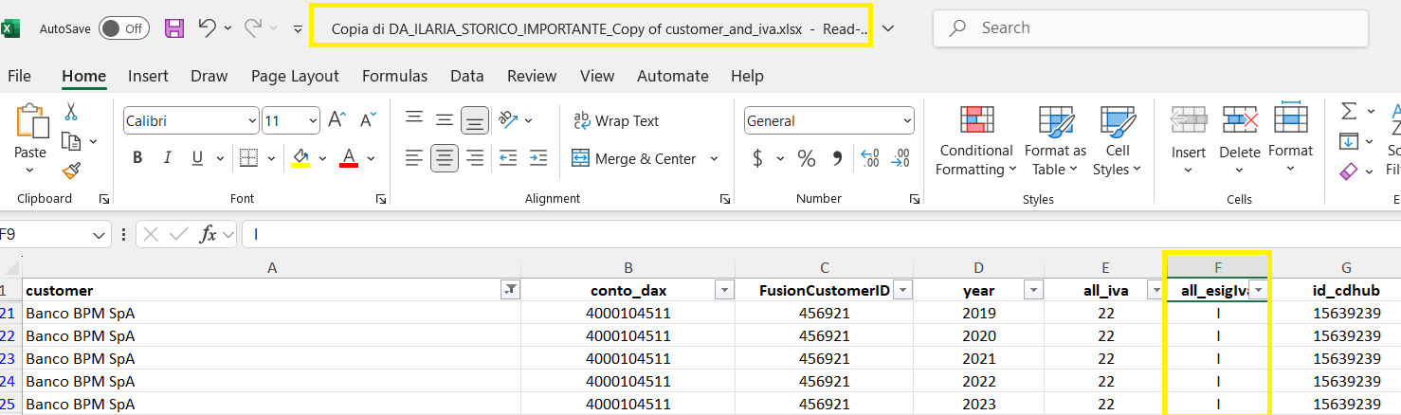

## Norway (630)

1. Click Manage Financial Project Plan

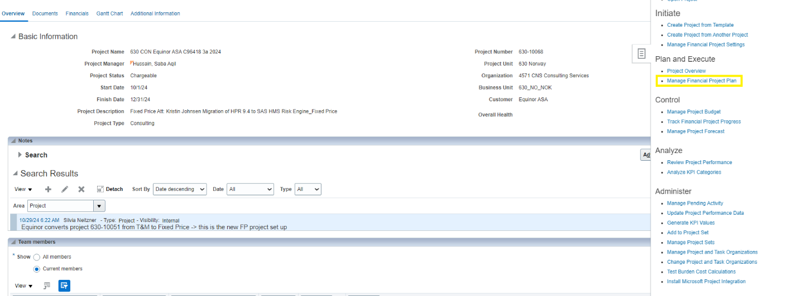

1. Click on View >Expand All Below

1. Under Resources column > click and check below highlighted manage resource Icon

1. Under manage resource icon - SR: Technical Consultant-Prn: Kyle, Carus

1. We need to check whether mentioned people under resources tab belong to same country or not if not than we need to tick in **Receive intercompany and interproject invoices** Box.

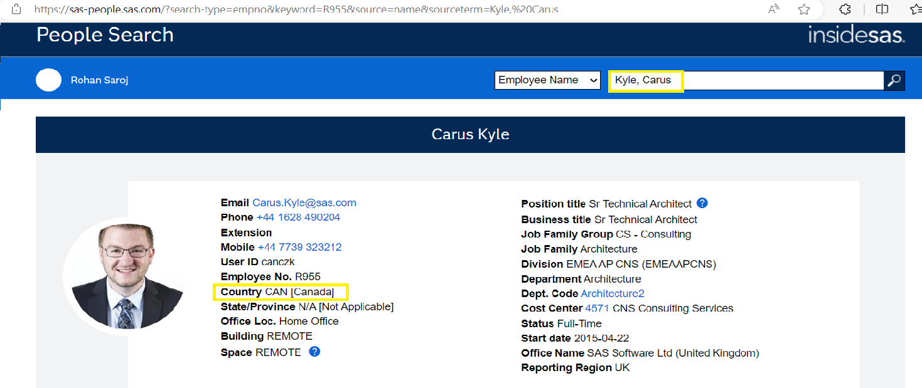

1. If we see mentioned people in the resources tab outside the Country tick mark in **receive Intercompany & Interproject Invoices.**

1. Link where we need to check the people’s country.

<https://sas-people.sas.com/?search-type=name&keyword=kyle+&bool=and>

## Denmark (520) & Finland (600)

1. While creating the budget, the revenue amount and billable hours is considered from the pricing tab of DPM instead of GAAP Finance tab.
2. We don’t change the project name and description of project as per US KT.

## Philippines (430), Singapore (435), Malaysia (436) and Thailand (437)

1. Saved the unlocked DPM (using password) at: [DAT_DPM folder with GAAP rate](https://sasoffice365.sharepoint.com/:f:/r/sites/ASEANDMOSharedServices2/Shared%20Documents/General/ORACLE%20FUSION/DAT_DPM%20folder%20with%20GAAP%20rate?csf=1&web=1&e=pQ0Qls&xsdata=%3D&sdata=N1hVYXhUOC9idjVGVHdZWWRndnRVRVhFZi93elIxVXFtTDRDcnI4S2pxUT0%3D&ovuser=b1c14d5c-3625-45b3-a430-9552373a0c2f%2CHimanshu.Singh.External%40sas.com) for the Project Reviewer for approval.

***Process End***

Escalation Matrix

|  |  |  |  |
| --- | --- | --- | --- |
| Name | Level | Email Address | Landline/Phone Number |
| Bhaswar Banerjee | Level 1 | bhaswar.banerjee@sas.com | N/A |
| Agnieszka Bartuzi | Level 2 | agnieszka.bartuzi@sas.com | +48 22 560 45 83 |
| Beata Kienorow-Gulan | Level 2 | beata.kienorow-gulan@sas.com | +48 22 560 45 69 |